ANDREW JEFFRIES

 | Independent Arbitrator |  | 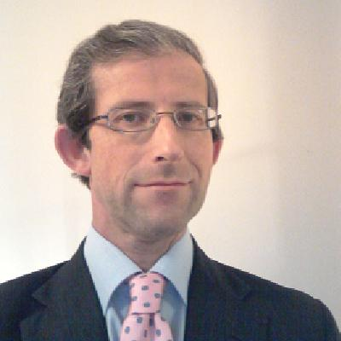
Qualifications: | Fellow, Chartered Institute of Arbitrators  Solicitor, Hong Kong  Civil Higher Court Advocate, England & Wales  Solicitor, England and Wales |  | 2006  2000  1997  1990
Positions Held: | Independent Arbitrator & Training Consultant  Partner, Joint Global Head of Corporate Litigation, Allen & Overy LLP, London  Partner, Head of Asian Dispute Resolution  Allen & Overy LLP, Hong Kong  Partner, Allen & Overy LLP, London |  | 2011 -  2008-2011  1999-2008  1998-1999
Since retiring from Allen & Overy in 2011, Andrew has pursued his career as an independent Arbitrator, and is an experienced Arbitrator acting as sole, party-appointed and presider. He is also an experienced Arbitration Counsel, specialising in the power, projects, energy and oil and gas sectors, as well as banking & finance related arbitration. He is a panel arbitrator for KLRCA and SIAC.

Since 1990 he has acted in arbitration disputes concerning such matters as PPA's in Malaysia, an infrastructure project in Vietnam, a power equipment company in India, confiscation of an oilfield in Nigeria, an oilfield in the Congo, the operation of two Philippines geothermal power plants, a port development in China, the Manila water and sewerage system, a Korean chemical plant, a Singapore incinerator power plant, and ISDA swap trade arbitration in the PRC. He is a UK Higher Court Advocate, and has conducted arbitrations as lead advocate.

He has acted as arbitrator or counsel under all the major arbitration rules and institutions, including KLRCA, ICC, ICSID, HKIAC, SIAC, CIETAC, LCIA and AAA.

In 2003 he was appointed as a Deputy Registrar of the High Court of Hong Kong. He was the author of Enforcement of Arbitration Awards in China for Sweet & Maxwell's Arbitration in China, A Practical Guide. He sat as a Hong Kong Council Member for the ICC, and was part of the Hong Kong Department of Justice committee on reform of the Arbitration Ordinance of Hong Kong. He was a member of the Law Reform Commission of Hong Kong, and the Law Society of Hong Kong Council.
Contact: Andrew Jeffries Born 1965, United Kingdom Citizen
154 Bundabah Road Australian Permanent Resident
Bundabah Email: aj@jeffriesarbitration.com
New South Wales 2324 Tel Aus: +61 (0) 4 9797 2487
Australia

